**بسم الله الرحمن الرحيم**

Sol-HW1

**الحل غير كامل**

**PART I:**

>>….

Private

….>>>

I set specifications of my VM 8 processors, 4GB RAM, 10GB storage of SSD.

Ubunty [Running] - O
racle VM VirtualBox

End of Part I

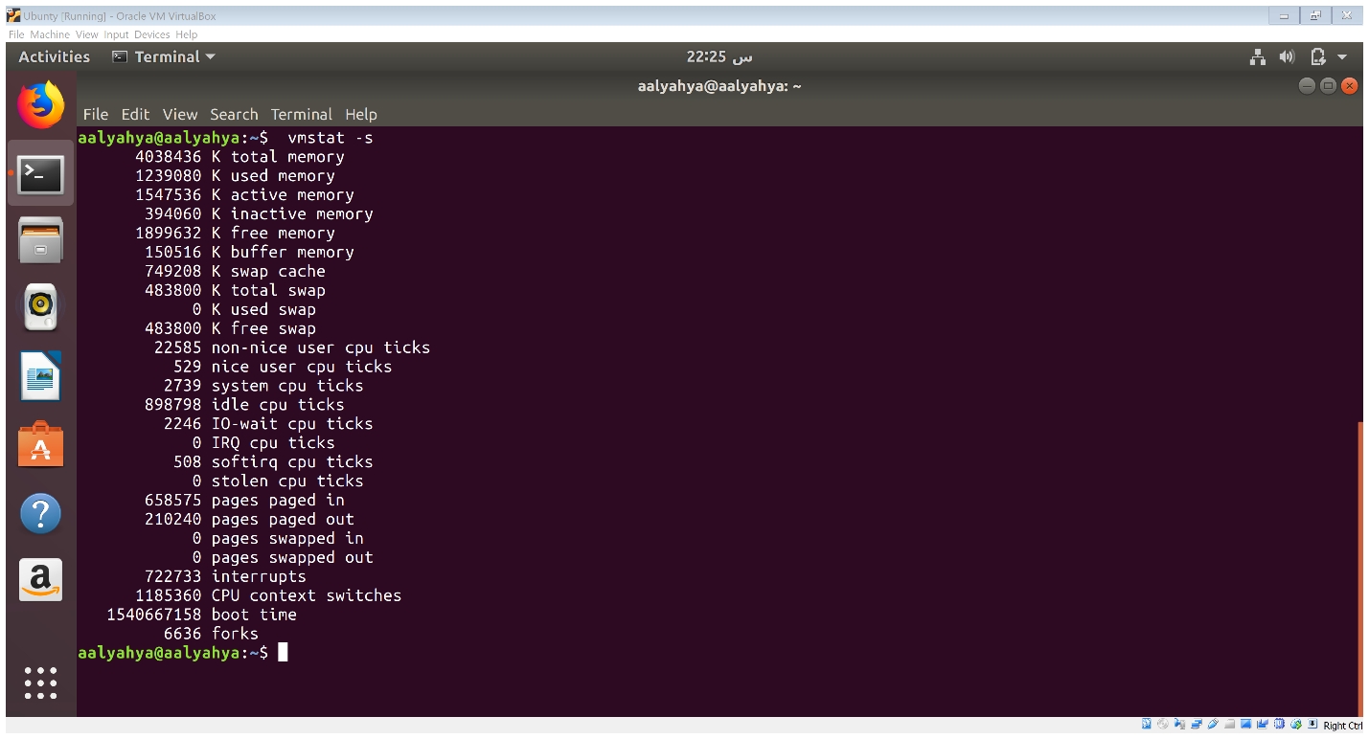**PART II:**

* The size of Memory for my VM is 4038436KB (4GB).
* The used Memory for my VM is 1239080KB.
* The free space in the Memory is 1899632KB.
* The size of the Swap for my VM is 483000.
* The used Swap if 0 KB.
* The free space of the Swap is 483000KB.

**The Five Processes:**

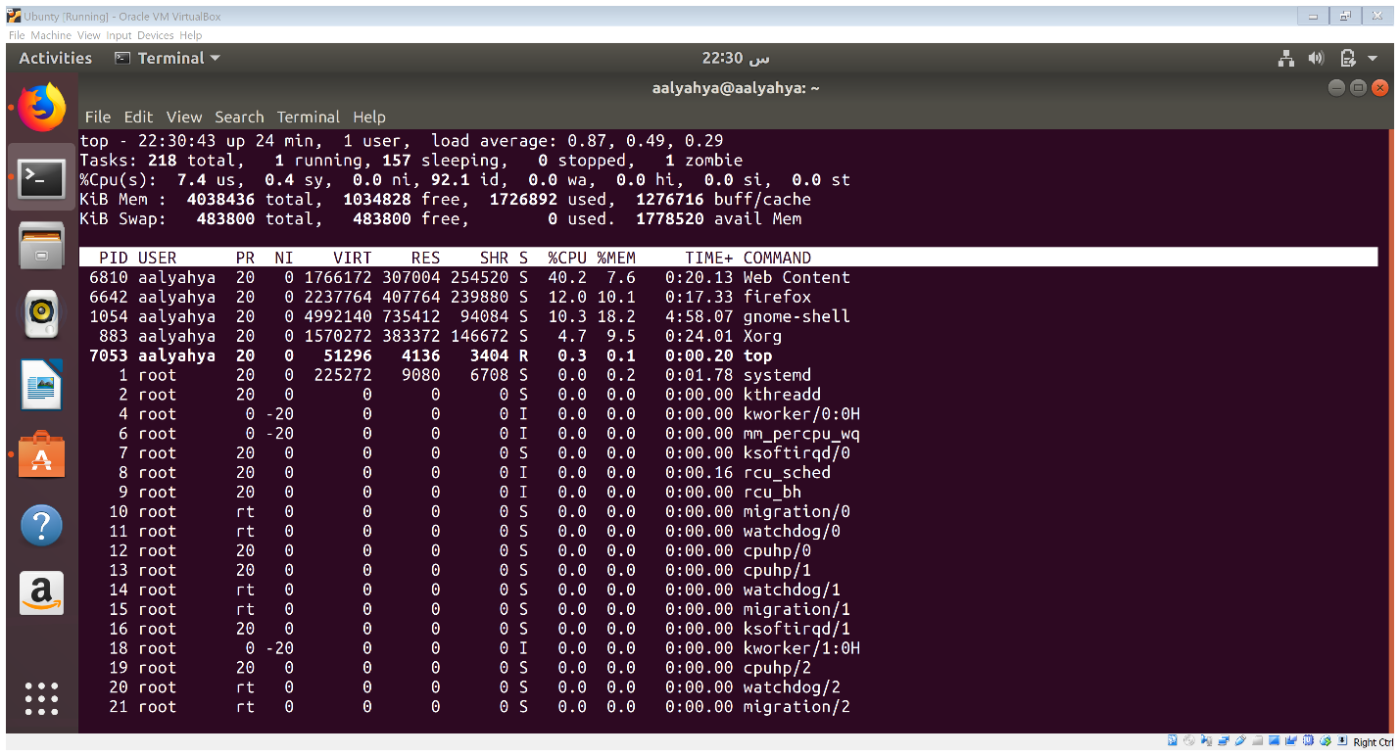

**PART III:**

System calls:

